✴

# Document an existing experience

**TIP**

As you add steps to the experience, move each these “Five Es” the left or right depending on the scenario you are documenting.

Narrow your focus to a specific scenario or process within an existing product or service. In the **Steps** row, document the step-by-step process someone typically experiences, then add detail to each of the other rows.

Customer experience journey map

Use this framework to better understand customer needs, motivations, and obstacles by illustrating a key scenario or process from start to finish.

When possible, use this map to document and summarize interviews and observations with real people rather than relying on your hunches or assumptions.

Created in partnership with

**SCENARIO**

**Browsing, booking, attending, and rating a local city tour**

**Steps**

What does the person (or group) typically experience?

## Interactions

What interactions do they have at each step along the way?

**People:** Who do they see or talk to?

**Places:** Where are they?

**Things:** What digital touch points or physical objects would they use?

# Entice

How does someone initially become aware of this process?

**Here from friends**

**online ads**

Feedback from customers

Merging with current technology

On observing the field where IOT based smart crop protection system is implemented.

Hears from experienced people whom already used IOT smart crop protection system

# Enter

What do people experience as they begin the process?

**Login to the app**

Location specification

Login with valid information customer details

Customer must provide the correct location type

Starts from information provided from demo

People doubt be hope it works

Welcome by some peoples and hesitated by traditional formers

# Engage

In the core moments in the process, what happens?

type of the soil present in the location should be provided by the user.

Soil type

crop data

Extension uncontrolled.

Prevention and positioning technologies.

They can send the message about the smart crop protection system. If any damage on the IOT DEVICE

The sensors senses the level of compound. the device sends the notification to the farmer

user can specify the crop they want to cultivate.

Easily report the current state of the crops to the farmer

Analyse the status of the crop

Website to monitor the crops level.

Information that can be shared with others.

# Exit

What do people typically experience

as the process finishes?

Awareness, prediction and warming system can reduce the disruptive impacts.

The user can contact if they have any hardness while using the app

Feel easy to monitor the crop

The device may send the wrong information

# Extend

What happens after the experience is over?

They feel hygiene crop protection system

Communication technologies to increase the quality and quantity.

It reduces the cost of production

Sensor can be damaged when animal intrusion

**Goals & motivations**

Help to increase crop production

Help’s to avoid work

Learning about device

Resources increases.

Well maintained form

Affordable to farmers.

Achieving better crop yields economic well being

Protecting their overheads and fields.

Save from significant financial losses.

To avoid the disruption.

The primary goal is to customer understand about and get benefit by using the product

At each step, what is a person’s primary goal or motivation? (“Help me...” or “Help me avoid...”)

## Positive moments

User friendly

They may recommended positive feedback about the app helps people to work with the apps.

People love to remote access control

managing database

positive impact in environment

Source of income in rural areas.

Reduce water consumption.

Increase productivity

Secure application

What steps does a typical person find enjoyable, productive, fun, motivating, delightful, or exciting?

## Negative moments

if learning become a challenging task one can't handle the app alone and should have people for assisting them

There will be hard learning processes and understanding

Failed to enter database.

Delaying in receiving OTP

It requires continuous internet connection to be successful

What steps does a typical person find frustrating, confusing, angering, costly, or time-consuming?

[**Share template feedback**](https://muralco.typeform.com/to/CiqaHVat?typeform-source=app.mural.co)

## Areas of opportunity

How might we make each step better? What ideas do we have? What have others suggested?

Provide simpler information about smart farming

Customer will know about the tremendous growth in agriculture.

Confirming the exit option by user.

This application can be used in terrace gardening.

By these technology most literate peoples are ready to do farming

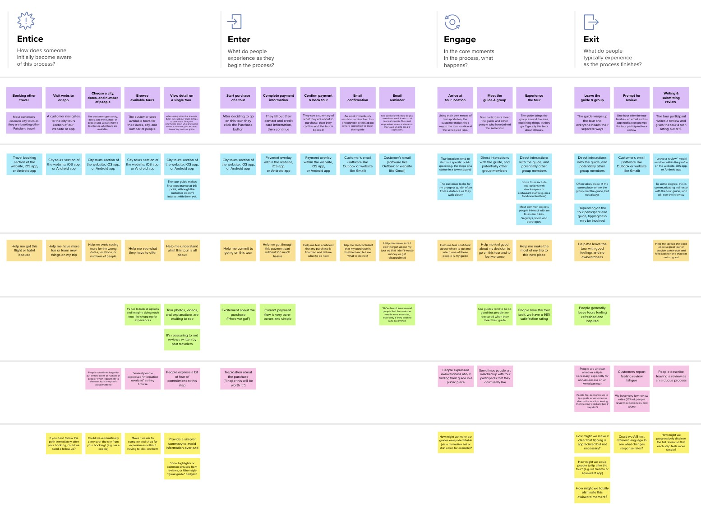

**Template**

**Need some inspiration?**

|  |  |  |  |  |  |  |  |  |
| --- | --- | --- | --- | --- | --- | --- | --- | --- |
|  |  |  |  |  |  |  |  |  |
|  |  |  |  | |  |  |  |  |

|  |  |  |  |  |  |  |  |  |
| --- | --- | --- | --- | --- | --- | --- | --- | --- |
|  |  |  |  |  |  |  |  |  |
|  |  |  |  | |  |  |  |  |

See a finished version of this template to Kick start your work.

[**Open example**](https://app.mural.co/template/f59f644b-b4b4-47b5-9ed6-3a8c71ceb612/896b31fe-5597-40ef-9b06-3811a1a45ace)